To

The

ENDS OF THE EARTH

Volume XXIII January - March 2012 Number 1-3

A work of churches of Christ

WHO IS A CHRISTIAN?

Editors Note: Guy Caskey (founder of Mission Printing) wrote the following article which was published in the July 1993 issue of “To The Ends of The Earth.” We believe it is still applicable today (almost twenty years later).

I would rather God would call me a Christian than any- one else. It is nice to have the love, respect and confi- dence of brethren in Christ, family and friends. No high- er commendation could be paid me than for those who know me to say, “He is a Christian.” This is far better than for them to acclaim, “He is great!” Or, “He is tal- ented.” Or, “He is rich and handsome.” For God to call a person a Christian is the most wonderful of all compli- ments. God called the disciples in Antioch “Christians” for the first time (Acts 11:26).

The prophet Isaiah said, “The Gentiles shall see your righteousness, and all kings your glory. You shall be called by a new name, which the mouth of the Lord will name” (Isaiah 62:2). This was fulfilled in the New Testament in Acts 11:26, “And the disciples were called Christians first in Antioch.” The word for called in this passage is not the common word used for call in the New Testament. This word is krematizo and is used nine times and Thayer says of its meaning, “In the New Testament, to utter a divine communication.” Four times it is translated warned of God, once it is rendered revealed by the Holy Spirit, once it is phrased admon- ished of God. You will note that whether, warned of God, revealed by God, admonished by God or called by God, that it was always God’s doing, His action. So, these early disciples were called Christians by a Divine utterance. God gave them this name.

The world has many standards by which it measures a Christian. The world thinks that a man who is good moral- ly is a Christian. Morality is important, but there were many good moral people before Christ came and gave Himself for the sins of mankind. Others think that a man who is honest, truthful, upright in his morals and pro- vides well for his family is a Christian. While all these things are commendable, and even necessary, they do not make one a Christian. In this lesson, we are inter- ested in who a Christian is when measured by God’s standard.

Peter gives us a full and satisfactory answer to this question of Who Is A Christian? in the first chapter of his first letter.

1. One who is an obedient child of God. “As obedi- ent children” (v. 14). The Twentieth Century New
Testament renders this, “Be like obedient children.” This means respect for authority, to hearken, listen to, total submission to the will of God. This person is like a child in submission to and dependence upon his par- ents. One has not been converted to Christ, hence is not a Christian, who has not surrendered himself, resigned his own will, to the will and pleasure of God.

We are living in a time when there is a great poverty of respect for authority in the home, school, society and the church. It is a monstrous sin to “do that which is right in their own eyes.” People of today, the world over, set up their own standards, fulfill their own desires, and walk in their own ways without respect or regard for con- stituted authority.

2. One who is holy. “But as He who called you is holy, you also be holy in all your conduct” (v. 15). This word means “separate from the common, one who has been set apart from the world and its evil,” The person who is a Christian is one who has been called out of the world and lives a life of purity, benevolence and service in God’s family.

Jesus said, “You are already clean because of the word which I have spoken to you” (John 15:3). In Chapter seventeen, He continues in His prayer to God, “Sanctify them through Your truth; Your word is truth.” So, when one has been made clean, separated from the world and lives a segregated life, he is a Christian, according to God’s definition. His behavior and deportment are now fashioned after God’s standard set for him. His life is now committed and dedicated to the service of the Savior. He is a new creature (Romans 6:4). Now he is easily distinguished from the man of the world.

3. He is one who calls upon God as his Father. “And if you call on the Father. . .“ (v. 17). This is one of the answers, Peter tells us, of Who Is A Christian? There are two apparent truths in the divine answer: (1) One must have the right to call God his Father and (2) He must exercise that right. Who has a right to call upon God as his Father? The answer is simple —the one who is in His family, either by birth or by adoption.

I have two children. They are in my family. They were born into it. Because they are in my family, they have a just claim to call me their father. It would be a moral reflection upon me, and upon my character as a Christian, for anyone who is not in my family to call me father.
(continued on next page)

1

Some years ago while visiting and preaching in Haiti, children would follow me along the streets and ask for gifts of money. One of these children thought he would have the advantage and would touch a respondent chord of my heart by stepping out in front of me and addressing me as father. He was not my child. I had never seen him before, and I did not know his mother. No man has the right to call upon God as his father who cannot produce the evidence of his sonship. “... unless one is born of water and the Spirit, he cannot enter the kingdom of God” (John 3:5). This plain statement of Jesus is exclusive and inclusive. It excludes those who do not submit their lives to the will of God by being born again and includes all who will do so with all of their hearts.

But let us not forget that a Christian is one who can call on God as Father, and who will exercise that right as a child of God daily. Far too many who have that right do not avail themselves of the wonderful privilege of talking to Him regularly. Do I give thanks for His goodness and invoke His blessings that I might be a better and more faithful child of His?

4. One who is a sojourner. “... conduct yourself throughout the time of your stay here in fear” (v. 17). A sojourner is a stranger, pilgrim, a temporary resident in a foreign land. It is a fleeting stay one spends in this life. Christians must not loiter on the way; they must press toward the goal. They are colonists who will soon be called to the mother country. Our deepest affinities con- nect us with heaven, for that is where our citizenship is.

It is unfortunate when we do not recognize that we are pilgrims passing through this world on our way to a bet- ter land. Some get so wonderfully attached to this world, as though it were their home, they have no wish to leave it. Some get so involved in the affairs of this life that they prefer to make this their permanent dwelling! If asked, they may tell you that heaven is their home, but they are not homesick yet.

I read somewhere this statement: “Were the happiness of the next world as closely apprehended as the felici- ties of this, it were martyrdom to live.” And another statement: “Two men may embark in one ship—the one full of good cheer as the ropes are loosed and the first turn of the screw begins to move her from the pier; the other sad because he leaves all that is familiar and dear. The one is going home from exile; the other is being borne into banishment in a strange land, whose speech he does not know, whose kind he does not serve. Which shall I be when death comes?’

5. One who has been redeemed in the blood of Christ. “Knowing that you were not redeemed with cor- ruptible things, like silver or gold, from your aimless conduct ..., but with the precious blood of Christ, as of a lamb without blemish and without spot” (v, 18-19). Redeem means “to set free, deliver from bondage for a ransom.” Once we were slaves to a selfish life in which we lived for personal gratification, the free indulgence of our appetites and passions. We were under the control and dominion of sin. But Jesus gave his life as a ran- som for us (Matthew 20:28; I Timothy 2:6). Now we are free in Christ and he charges us to “stand fast in the lib- erty wherewith Christ has made us free.”

6. One who believes in God who raised Christ from the dead (v. 21). Belief in God who raised Christ from the dead is fundamental to our being Christians. In the so-called Christian world today, there are many who affirm their belief in Christ—that He was a great man, a wonderful teacher and one who formulated the highest system of ethics of anyone who ever lived. But in the same breath, they deny that He was raised from the dead. The New Testament is replete with statements of His resurrection, and if we do not believe in the word of God on this subject, why accept it on any other? “And killed the Prince of life, whom God has raised from the dead” (Acts 3:15). No man is a Christian who does not believe that God raised Jesus from the dead.

“Let it be known to you all, and to all the people of Israel, that by the name of Jesus Christ of Nazareth, whom you crucified, whom God raised from the dead, by Him this man stands before you whole” (Acts 4:10). Paul told the Romans that He “was delivered up because of our offences, and was raised for our justifi- cation” (Romans 4:25). He had already told these Christians: “If we believe on Him who raised up Jesus our Lord from the dead.”

7. One who has purified his soul in obeying the truth —(v. 22). There are three words in this passage to which we should give attention: (a) Obedience. The meaning of this word in the New Testament is that of hearing— listening and being submissive to the will of Christ. It also points up personal responsibility. They had a part in bringing about their purification. (b) Truth. A familiar statement of Jesus is: “You shall know the truth and the truth will set you free” (John 8:32). Knowing and obeying the truth Jesus taught will make men free. (c) Purified. This word describes the moral and spiritual state into which they entered when they obeyed, and in their continued obedience they con- tinued to be purified.

8. One who has been born again (v. 23). The new birth has often been presented as a mysterious, inex- plicable process beyond human grasp. But Peter explains what the new birth is and how it is brought about. He tells us in this chapter that we have been re- deemed by the blood of Christ. That’s God’s part in our salvation. His next step is that we have been purified in our obedience to the truth. This is man’s part. Redemption in the blood of Christ and purification of our souls in obedience to the truth constitute the new birth, for it is the same verse that says, “being born again” of the living and abiding word, the gospel which has been preached to us.

9. One who entertains the hope of an eternal inher- itance (v. 4). When one becomes a Christian by being obedient to God’s word and continues faithfully in the Christian life, he entertains a hope of a home in heav- en. What a wonderful promise! What a sustaining expectation! It is an inheritance immortal, deathless, imperishable, unfading. The permanence, the ev- erlastingness of this reality should prompt faithfulness in all of us. -- Guy Caskey

2

TOUCHING THE WORLD
LETTERS AND EMAILS FROM THE FIELD

Zimbabwe, Africa
My brother, thank you very much for sending us a box full of biblical tracts. The attached picture shows our student helper Prisca collecting the parcel from Morningside Post Office. If you have more tracts, please send them over because we aim to recruit
1000 students at the Zimbabwe International Trade fair in April this year. May God bless you.

In His service,
Velaphi Mlangeni, in Bulawayo Zimbabwe
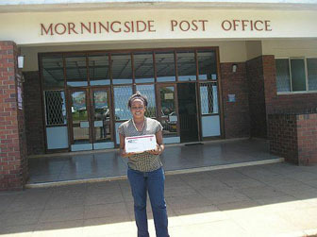

Johannesburg, South Africa
We are knocking doors, distributing gospel tracts, talking to folks about the church. I will highly appre- ciate it if you folks can pray for us as we will reach- out in our community speaking for the Master. We sincerely want to ask for a large amount of gospel tracts, Bibles if available, and song books. We sup- ply our sister congregations around Johannesburg with tracts and other material since many in our con- gregations and communities are unemployed, and we are planning to have a tract drive in each term in
2012 which means we are going to run out of mate- rial. We will highly appreciate any tracts, Bibles, song books to the furtherance of the gospel in our community and surrounding areas in our country. Thank you so much for your prayers, love, support, appreciate you folks so much.

Your fellow servants, Phillip & Michelle King

Dear Saints,

Zambia, Africa
Cambridge, England
Brian Chadwick (right) and his wife are handing out Mission Printing tracts as well as World Bible Correspondence Courses to help those in the U.K. learn more about God and His Church.
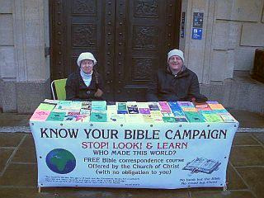

Re: Spiritual reading Materials for Evangelism work and for building Christians

Best regards to you all in the mighty Name of our Lord and
Savior Jesus Christ, the only source of life everlasting.

I want at this moment cry for help of spiritual reading materials which can help both the old and new con- verts understand God's will and make them grow in Christ. Again as we all know that it is our task and duty to reach the lost and without commitment we cannot manage, but let us all remember that we have it and have to do it on behalf of God. I as well appeal for few copies of Bibles with "Not for Sale Tag" and Tracts too.

God bless you all,
Kamushele David Smart, Evangelist - Kaunda Square
Church of Christ

3

Uganda, Africa
We have planted another congregation here in
Kamplala and they have no song books. The work
here is progressing, but it’s still hard to sustain the
young men we are sending there to preach and
mature the young congregations we are planting.
Please keep us in your prayers,
Mwizerwa Emmanuel

Volunteer
Corner
Mission Printing has been and continues to be blessed by many wonderful volunteers, without which our work would be impossible. These dedicat- ed people give of their time and talents to send the gospel to the ends of the earth. In this issue we high- light two of these longtime faithful volunteers who will celebrate their 90th birthday in April.

Alice Walker and her husband, Lloyd, moved to Arlington in the early 1980's and shortly became volunteers at Mission Printing. Lloyd was a regular and faithful printer, and it was a great loss when he passed away in 1991. Alice became a devoted full time volunteer for our operation, and contin- ued on a full time basis for about twenty-five years. Alice filled several roles such as: secretary, bookkeeper, office manager, editor, and did proofing and preparing material to be printed. Early on, she learned how to use computers for word processing and typesetting. As our printing systems advanced and became more computer based, she learned the new software and became our “expert” at using the Quark typesetting program.

Due to failing eyesight and other health problems, within the last two years or so, Alice is no longer able to perform many of the tasks she did so well. However, she is not deterred and continues to come to Mission Printing on Tuesdays with the College Hill group. The bus stops by to pick her up and then takes her back home. She is still ded- icated to the Lord's work.

We wish Alice a "Happy Birthday" and want to thank her for the many years of service to the Lord's work here at Mission Printing. Her enduring dedication to this work is undoubtedly responsible for much of our success.

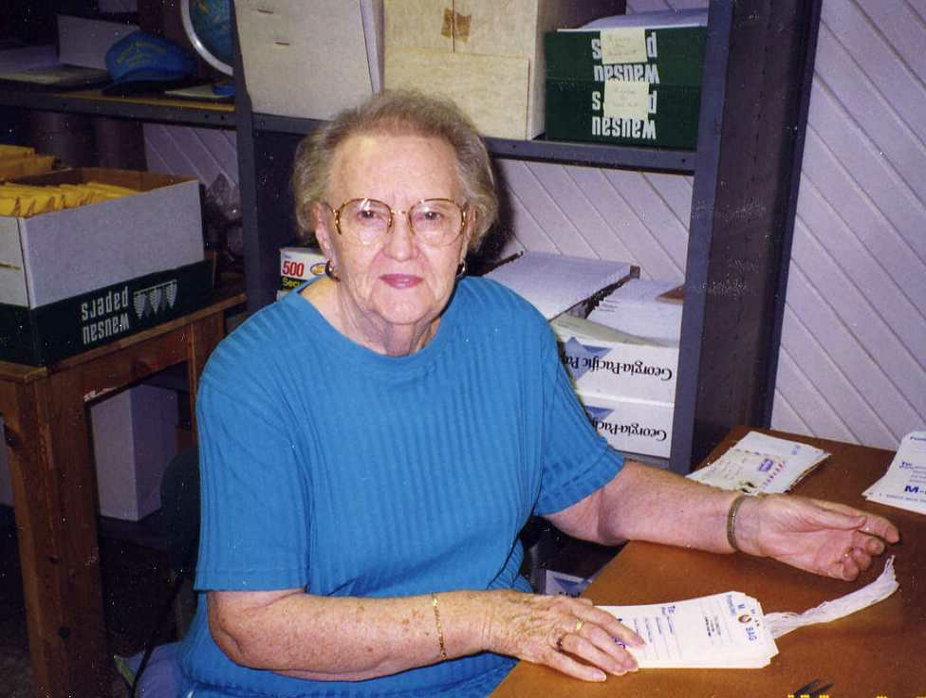
Dot Dawdy

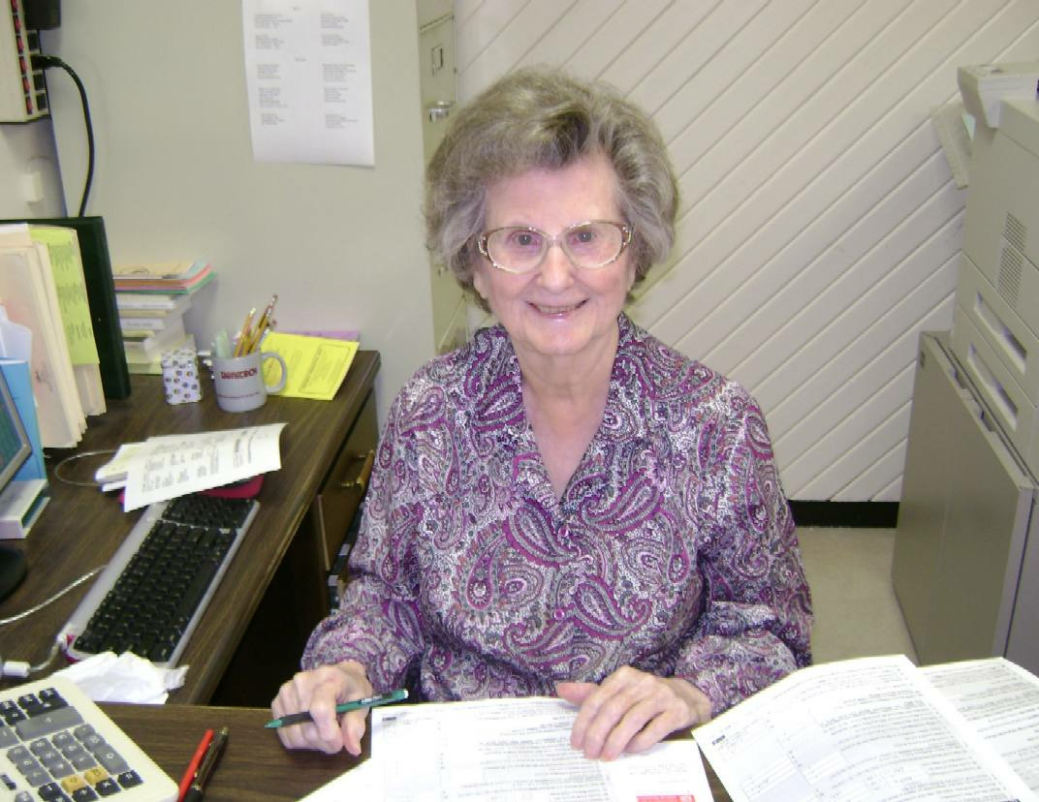
Alice Walker

Dot Dawdy and her husband, Bink, moved to Arlington in the early 1980's. After his retirement in 1983, Bink became a full time volunteer for Mission Printing and served several years as President of the Board of Trustees until his death in 1995. Dot also became a reg- ular volunteer, working at least two days a week. She worked in the mail room, reading letters from the field and filling requests for materials. She addressed shipments to be sent to destinations all around the world and kept records of the shipments. Dot also did collating and assembly of booklets and tracts.

Dot has been one of our most dedicated volunteers and supporters. This godly woman exudes a congenial spirit and positive attitude and is a joy to be around. Not only has she given us many years of her time and talents, but she also has generously supported us with monetary gifts. Mission Printing could not have grown to be what it is today without fine Christian people like Dot Dawdy.

Dot moved to The Woodlands, TX about a year ago to be nearer to her daughter. We miss her greatly at Mission Printing and hope she is enjoying her new home. "Happy Birthday" wishes go out to Dot and may God bless her in all her future endeavors. We will forever be grateful for all she has done for the Lord’s work here at Mission Printing.

4

MEMORIALS & HONORS

(DECEMBER 1, 2011 TO MARCH 31, 2012)

Memorials
Anderson, Frank
Renfro, Richard & Carolyn
Ann
Hubbard, Sue
Armstrong, Evelyn Armstrong, Melvin Belcher, Ashley Grice, Marie
Price, Roberta Salem, Joe & Mabel Seidmeyer, Henry Scott, Mary
Arterburn, Harold Arterburn, Alma Ashworth, Maury Ashworth, Ilene
Ashworth, Ray
Ashworth, Ilene
Asimakis, Gregory K. "Harry"
Farquhar, Jean Graves, Eileen Austin, Betty Jean
Wise, Mary
Ballew, Evelyn Arterburn, Alma Moulder, Janette
Basford, Barry Glenn
Basford, Bobby & Eva
Basford, Bobby Jr.
Basford, Bobby & Eva
Baty, Sam
Fenner, Sharon & Milton
Beene, Dorothy
England, Herman & Paulette
Bennett, Eugene Anonymous Braziel, Scherry
Cathey, Emery & Ann Zene Foley, Paul & Dorothy Gaskill, Kay
Hogue, David & Micki Middleton, Bob & Lavelle Pressley, Loy & Kaye Savage, Jerome & Leah Snyder, John & Frances Wade, Gene & Vicki
Birkhead, Stan
Tarver, Cleo & Judy
Bottoms, Steve & Gladys
Basford, Bobby & Eva
Brown, Richard
Graves, Eileen
Brown, Virgil Bradshaw, Curtis Caskey, Louise
Holcomb, Phillip & Conya
Teague, John & Juanita
Todd, Glenda
Watson, Eugene & Jacqueline
Burgess, Eva
Nelson, Vinus & Jean
Burnham, Paul
Graves, Eileen
Burnham, Virginia
Friends @ Handley Church of Christ
Chastain, Bill
Wade, Rozalea
Christie, Benny
Braziel, Scherry
Cathey, Emery & Ann Zene Coats, Frankie & Barbara Cook, Nell
Foley, Paul & Dorothy
Gaskill, Kay
Hogue, David & Micki Melancon, Charles & Terri Middleton, Bob & Lavelle Parrish, Robert & Margaret Porter, Lummie & Linda Pressley, Loy & Kaye Slatter, Raymond & Nelda Snyder, John & Frances Tipton, Dewey & Freda Vess, Judy
Crouch, Joseph & W. Yvonne
Scott, Mary
Daugherty, Nancy
Wade, Rozalea
Degge, Kyle
Caskey, Louise
Dickerson, David
Thornton, Charles & Norma
Dickey, Charles Anonymous Duncan, Audra
Oberlin Church of Christ
Edgar, Margaret
Braziel, Scherry
Cathey, Emery & Ann Zene
Cook, Nell
Foley, Paul & Dorothy
Gaskill, Kay
Hogue, David & Micki Kinslow, Roy & Reba Melancon, Chuck & Terri Parrish, Robert & Margaret Porter, Lummie & Linda Potts, Henry & Maxanne Pressley, Loy & Kaye Slatter, Raymond & Nelda Snyder, John & Frances Tipton, Dewey & Freda
Evans, Carl
Tarver, Cleo & Judy
Farrar, Michael
Friends @ Handley Church of Christ
Forbus, Raymond Baker, Jerry & Laquita Renfro, Richard & Carolyn Ross, J. C. & Dessie
Forrest, Harley
Garner, Frances

5
Wasner, Hans & Mary
Gilbert Sr., Jack Cruse, Bob & Shirlee Guthrie, Morris & Melba Hobby, David & Karen
Goffinet, Greg
Guthrie, Morris & Melba
Gunter, Don
Gunter, Peggy
Haralson, Boots Arterburn, Alma Dickey, Dorothy Moulder, Janette
Harlow, Grasson
Hartin, Hubert & Walterrene
Hassell, Mary
Parker, Mary Lou
Hinson, Charlie & Ora
Hinson, John & Pat
Holt, Jimmy
McKee, Doris
Holveck, Mildred Audrey
Taylor, Robert & Cathy
Hood, Helen
Herriage, Bob & Sue
Reinhardt, Peggy
Hubbard, Sue
Barron, Shirley
Friends @ Handley Church of Christ
Fuller, Robert & Becky Handley Church of Christ Hiltibidal, Jessie
Hyde, Myrtle Tarver
Hinson, John & Pat
Jobe, Marilyn
Tarver, Cleo & Judy
Johnson, J.Y.
Arterburn, Alma
Cannon, James & Margaret
Dickey, Dorothy
Highland Church of Christ Saints
Moulder, Janette Pendergras, Willa & Rick Winkler, Mary
Johnston, Kristen
Mulanax, Mr. & Mrs. Hoyt
Kelly, Jean Price, Roberta Scott, Mary Seidmeyer, Henry
Knebusch, Madison Nelson, Vinus & Jean Vincent, Roy & Jettie
Lowe, Foy
Jennings, John & Oleta
Martin, Joyce
Ford, Jo
McCaghren, Jim
Wasner, Hans & Mary McFarlin, John Parker Lewellyn, Jess & Ann
McKinney, Ronnie Eugene
Highland Church of Christ Saints
Mimms, Glenn (Pete)
Lewis, Don & Margaret
(continued on next page)

Mitchum, Tommy
Brown, Fred & Edna
Moe
Hubbard, Sue
Newhouse, Beverly
Graves, Eileen
Nichols, Phil
Cruse, Bob & Shirlee
Norman, Cody
Norman, Ron & Jackie
Norman, Melissa
Norman, Ron & Jackie
Offutt, Sara
Guthrie, Morris & Melba
Osborne, Bill
Nelson, Vinus & Jean
Parks, E. L.
Arterburn, Alma
Cannon, James & Margaret Highland Church of Christ Saints Winkler, Mary
Pate, Doug
Basford, Bobby & Eva
Pearcy, Odeal & Loraine
Shour, Carol
Pearson, Bob
Cruse, Bob & Shirlee
Proffitt, Claribel
Cruse, Bob & Shirlee
Randall, Jon
Lewellyn, Jess & Ann
Reynolds, Edith
Cruse, Bob & Shirlee
Riley, Maxine Anonymous Braziel, Scherry
Cathey, Emery & Ann Zene
Cook, Nell
Foley, Paul & Dorothy
Gaskill, Kay
Melancon, Charles & Terri Middleton, Bob & Lavelle Porter, Lummie & Linda Potts, Henry & Maxanne Pressley, Loy & Kaye Snyder, John & Frances Tipton, Dewey & Freda Vess, Judy
Wade, Gene & Vicki
Williams, Landon & Kristi
Rogers, Sheryl Ashworth
Ashworth, Ilene
Runyun, Beth
Barker, Clifford & Audrey
Scott Sr., Albert E.
Scott, Mary
Short, Mack
Basford, Bobby & Eva
Simmons, James Robert
Braziel, Scherry
Cathey, Emery & Ann Zene
Cook, Nell
Foley, Paul & Dorothy
Gaskill, Kay
Hogue, David & Micki
Melancon, Charles & Terri
Middleton, Bob & Lavelle Potts, Henry & Maxanne Pressley, Loy & Kaye Savage, Jerome & Leah Snyder, John & Frances Wade, Gene & Vicki
Sister of Darrell Jester
Robinson, Mr. & Mrs. David
Smith, Larry
Smith, Dillion & Joyce
Stevens, Laura Mae
Wasner, Hans & Mary
Tarver Sr., Cleo
Hinson, John & Pat
Tuley, Sonny
Snyder, John & Frances
Warner, Clyde
Braziel, Scherry
Cathey, Emery & Ann Zene
Cook, Nell
Foley, Paul & Dorothy
Gaskill, Kay
Hogue, David & Micki Melancon, Charles & Terri Middleton, Bob & Lavelle Pressley, Loy & Kaye Snyder, John & Frances Vess, Judy
Wade, Gene & Vicki
Wasner Sr., Hans
Barker, Clifford, Audrey
Woodward, Daisy
Watson, Ray & Margret
Harris, Joyce
White, Lonnie
Nelson, Vinus & Jean
Wiggins, Mel
Wiggins, Hattie
Williams, Shirley Foster
Elliott, Bernadine
Winkler, George
Dean, Martha
Highland Church of Christ Saints
Locke, Reta Moulder, Janette Moyers, Dottie Pendergras, Willa Roberts, Phyllis
Wolfe, Holly Isbell, Mildred Mom
Woodard, Clifford
Braziel, Scherry
Cathey, Emery & Ann Zene Coats, Frankie & Barbara Cook, Nell
Foley, Paul & Dorothy
Gaskill, Kay
Hogue, David & Micki Melancon, Charles & Terri Parrish, Robert & Margaret Porter, Lummie & Linda Pressley, Loy & Kaye Slatter, Raymond & Nelda Snyder, John & Frances Tipton, Dewey & Freda Vess, Judy
Youngman, Mickie
Wight, John & Nancy

Honors

Armstrong, Melvin
Seidmeyer, Henry
Bradshaw, Curtis
Caskey, Louise
Buck, Bill & Jeannie
Conley, Charles & Donna
Hamilton, Huey
Houston, Travis & Alfreda
Jackson, Rod
Caskey, Louise
Kelly, Glen
Seidmeyer, Henry
Mission Printing Workers
Russwurm, Rusty & Sue
Moore, Nina
Houston, Travis & Alfreda
Mosely, James W.
Ramirez, Paul & Lottie Sam

Birthday

Berry, Jean (90th Birthday)
Lewellyn, Jess & Ann
Birdwell, Eleanor (90th Birthday)
Beam, Chester & Debbie
Potter, Jack
Burton, Texana (Birthday)
Lewellyn, Jess & Ann
Caskey, Jessie Lee (92th Birthday)
Garner, Tom & Ouida
Tarver, Cleo & Judy
Cotham, Perry (100th Birthday)
Jones, Linda
Fenner, Mykayla (13th Birthday)
Fenner, Grandma & Grandpa
Jones, Gearldean (Birthday)
Renfro, Richard & Carolyn

Anniversary

Fowler, Mr. & Mrs. Grady (50th Anniversary)
Renfro, Richard & Carolyn

6

Individual & Group
Financial Supporters
2011

Allen, Darrell & Melissa Anderson, Billy & Shirley Anderson, Dorothy Anonymous
Armstrong, Melvin & Evelyn
Arterburn, Alma
Atherton, Eddie & Deborah
Atherton, Hilah Atherton, Scott Austin, Esta Bachman, Mary
Bailey, John & Rosalyn Baker, Mr. & Mrs. Jerry Basford, Bobby & Eva Batot, Mike
Baumwart, Donna Beavers, Gene & Joyce Belcher, Ashley
Bell, Art & Fern Benedict, Larry & Pat Berg, Gene & Geneva Berry, Robert
Bickley, George & Marcel
Birdwell, Eleanor Bishop, Pat Blacketer, Loretta Blaschke, Irma Blythe, Betty Boyd, Alan
Boyd, Bob & Kathleen Bradshaw, Curtis Braziel, Scherry Brinkley, Donna
Brooks, William & Katherine
Brown, Fred & Edna Brown, Melvin Brown, Virgil
Brown St. Church of Christ Ladies Class
Bryant, Oris & Tommie Burgess, Chal & Doris Burnham, Juanita
Buzz-Off Pest Service
Campbell, Laura
Cannon, James & Margaret Carrico, Gerald & Sally Carroll, Eugene & Loretta Carroll, Bruce & Mary
Case, Travis & Patricia
Caskey, Louise
Caskey, Raymond & Nell
Cates, Norman
Cathey, Emery & Ann Zene
Chandler, Charles Chanslor, Marguerite Cherry, Tom & Jean
Citizen Police Academy #19
Cleveland, Deborah Cloud, Tony & Miriam Cobb, R.C.
Cockrell, Susan Coffey, Jerry & Jeane Cohn, Gary & Judy Conley, Charles & Donna Cook, Nell
Coplan, Alice Jean
Cotham, Perry
Crow, Mildred Randolph Cruse, Robert & Shirlee Davis, Rickey
Dawdy, Dot
Dickey, Dorothy
Dollarhide, Vendall & Elizabeth
Donley, Neil & Nancy Drake, Calvin & June Dry, Johnnie
Dubcak, Julie
Dunn, Jimmy
DuPriest, Harvey & Patsy
Elliott, Bernadine
England, Herman & Paulette Enloe, Dr. John & Juanita Fallis, Hazel
Farquhar, Jean
Findley, Mr. & Mrs. Jack
Fisher, Murphy
Foley, Paul & Dorothy
Ford, Jo
Friends @ Handley Church of Christ
Gardner, Ken Garner, Frances Garner, Tom & Ouida
Garrison, Mike & Elizabeth
Gaskill, Kay
Grantham, Marion & Jerry
Graves, Eileen Grice, Marie Gunter, Peggy
Guthrie, Morris & Melba Habermehl, William & Sue Hales, Bud
Hammons, Calvin & Betty
Hammons, Roxie Hanes, Roben & Carol Harbison, Dale & Amy Harding, Jo Ann Harding, Sam
Hardy, Frankie
Harris, Joyce
Harston, Frank & Sylvia Hartin, Hubert & Walterrene Harwell, Lorene
Hays, Phillip & Nannie Henderson, Kathy Henson, Sybil Herriage, Bob & Sue
Highland C of C Saints Hiltibidal, Jessie Hinson, John & Pat Hladik, Chris & Tina Hobby, David & Karen Hodgkins, Dana
Hogue, David & Micki Holcomb, Phillip & Conya Holloway, Robert & Billie Houston, Travis & Alfreda Hubbard, Sue
Hutchison, Doris Isbell, Mildred Jaynes, Tolbert Jenkins, Jeff & Laura
Jennings, John & Oleta Johnston, Roy & Addie Jones, Currey & Patricia Jones, Delbert & Jean Jones, Ed & Ann
Jones, Gary & Allison Jones, Ken & Dorothy Jones, Lea
Jordan, Webb & Ruth
Kelly, Glen
Kemplin, Carl & Anna Kinslow, Roy & Reba Kiser, Charlie & Lynette Kiser, Terry & Donna
7
Know Your Bible
Lackey, David & Darlene Lackey, Elijah & Evelyn Lander, Ken
Lander, Willena & Karen Leatherman, Pauline Lewellyn, Jess & Ann Lewis, Don & Margaret Lewis, Ray & Barbara Light My Path Ministries Linville, Randy
Litton, Mrs. J.D. Martin, Bobby & Linda Martin, Ellen
Mayer, Lewis & Anna McBroom, Connie McCauley, Ruth McClung, Paul McCoy, Bob
McCrary, Jim & Sue
McKee, Doris
McKenney, Frank & Anita
McLeroy, Lorene McNeil, Dick & Barbara Melancon, Charles & Terri Melton, Lane & Judy Middleton, Bob & Lavelle Miller, David & Bonnie Mimms, Kati
Mitchell, Mike
Mitchell-Pouncy, Phyllis Moore, Eddie & Syble Morris, Gene & Nan Morrison, Bob & Mosa Mosby, Ed
Moulder, Janette
Munden, Nadine
Munden, Phillip & Darlene
Nahrgang, W. Lee Nelson, Agnes Nelson, Vinus & Jean
Nevil, Garland & Judith
Newton, Onnie Odem, Grace O’Pry, Sherrie Orr, Ruth
Padermos, John & Dorothy
Parker, Mary Lou
Parrish, Robert & Margaret
Partridge, Carol Paul, Grady & Ruth Pendergras, Willa Persley, John & Barbara Peterson, Linda
Philley, George & Edith
Pirkle, Peggy
Pleasant Ridge C of C Care Group 13
Porter, Lummie & Linda Potts, Henry & Maxanne Pressley, Loy & Kaye Preston, Jim
Preston, Terry & George
Price, Roberta Pullen, Norma Rabeck, Olene
Ramirez, Paul & Lottie Sam
Ramsay, David Reddell, Jimmie Reed, Marceline Reinhardt, Peggy
Renfro, Richard & Carolyn
Rhudy, Connie Richardson, Mike Richardson, Norma Riggs, Joyce
Roane, Wilbur & Wanda
Roberts, Phyllis
Robeson, Charles & Clista Robison, David & Sandra Ross, J. C. & Dessie Russwurm, Rusty & Sue Rye, C.D.
Salem, Joe & Mabel
Samsill, Loretta
Savage, Jerome & Leah
Scott, Mary Seidmeyer, Henry Shelfer, Tim & Jan Shipley, George & Bertie Shour, Carol
Shumate, Clif
Sickles, Maxie
Singleton, Raymond & Charlene
Slatter, Raymond & Nelda Smith, David & Jeanette Smith, Dillon & Joyce Smith, Joseph
Sneed, Thelda
Snyder, John & Frances Springer, Wilson & Frances Stidolph, Rob & Deb
Stull, Virginia Summers, Olin Tarver, Cleo & Judy Taylor, Betty
Taylor, Robert & Cathy Teague, John & Juanita Thomas, Roy & Helen Thornton, Charles & Norma Tipton, Dewey & Freda Todd, Glenda
Townsend, Leo & Carol
Tye, Audra
Underwood, Eugene & Mary Jane
Varner, Bill & Audrey Vernon, Samuel & Linda Vess, Judy
Vincent, Roy & Jettie Vinson, Walter & Jerry Wade, Gene & Vicki Wade, Kristy
Wade, Rozalea Walker, Bill & Sandra Walker, Dorris & Janie Walling, Harold & Theda Walters, T. H. & G. J. Wasner, Hans & Mary
Watson, Eugene & Jacqueline Weatherford, Fran (Snider) Weaver, Vinita
Webb, Dean & Joy West, Margaret Western, Peggie Wharton, Eloise White, Bill & Mary White Rock Fund
Whittington, Stewart & Dorothy
Wiggins, Hattie
Wight, John & Nancy Williams, Landon & Kristi Wilson, Ruby
Winchell, Myrtle Wise, Mary Ellen Woitalla, Carol Woodward, Daisy Workman, Betty
World Literature Fund Wright, Kevin & Chenell Young, Dub & LaVerne
Congregations Financially Supporting Mission Printing In 2011
(R - Regular Financial Supporter, # of members follow each congregation)

Angleton Church of Christ (Angleton, TX) 200
Bedford Road Church of Christ (Bedford, TX) 100
Bellville Church of Christ (Bellville, TX) R 73
Brown Trail Church of Christ (Bedford, TX) R 350
Clinton Church of Christ (Clinton, MS) 80
College Hill Church of Christ (N. Richland Hills, TX) R 380
Crestview Church of Christ (Waco, TX) 550
Crockett Church of Christ (Senatobia, MS) 60
Downtown Church of Christ (Cedar Hill, TX) R 140
East Tallassee Church of Christ (Tallassee, AL) 160
Emory Church of Christ (Emory, TX) R 133
Fourth & Stewart Church of Christ (Brownwood, TX) R 120
Hartford Ave. Church of Christ (Ponca City, OK) 200
Highland Church of Christ (Fort Worth, TX) R 208
Hiwasse Church of Christ (Hiwasse, AR) R 55
Howe Church of Christ (Howe, TX) R 165
Ivanhoe Church of Christ (Ivanhoe, TX) R 36
Keller Church of Christ (Keller, TX) R 428
Lakewood Village Church of Christ (Fort Worth, TX) 65
Liberty Hill Church of Christ (Liberty Hill, TX) R 90
Longmire Rd. Church of Christ (Conroe, TX) R 200
Longview Church of Christ (Longview, TX) R 200
Nettleton Church of Christ (Jonesboro, AR) R 500
New Cross London Church of Christ (London, England) New York Ave. Church of Christ (Arlington, TX) 300
North Hills Church of Christ (San Antonio, TX) Pecos Church of Christ (Pecos, TX) 120
Seven Points Church of Christ (Seven Points, TX) 75
Smithfield Church of Christ (N. Richland Hills, TX) R 50
South Main Church of Christ (Weatherford, TX) R 480
Terlingua Church of Christ (Terlingua, TX) 7
University Church of Christ (Tyler, TX) R 150
Velvet Ridge Church of Christ (Bald Knob, AR) 150
Woodland Oaks Church of Christ (Spring, TX) R 330

Congregations With Volunteer Support
At Mission Printing in 2011

Bedford Road Church of Christ (Bedford, TX) Beltline Road Church of Christ (Irving, TX) Brown St. Church of Christ (Waxahachie, TX) Bridgewood Church of Christ (Fort Worth, TX) Brown Trail Church of Christ (Hurst, TX)
College Hill Church of Christ (N. Richland Hills, TX) Crowley Church of Christ (Crowley, TX)
Downtown Church of Christ (Cedar Hill, TX) Emory Church of Christ (Emory, TX)
Freetown Road Church of Christ (Grand Prarie, TX) Grandbury Church of Christ (Grandbury, TX) Handley Church of Christ (Fort Worth, TX)
Highland Church of Christ (Fort Worth, TX)

Hillsboro Church of Christ (El Dorado, AR) Keller Church of Christ (Keller, TX) Lewisville Church of Christ (Lewisville, TX)
Longmire Rd. Church of Christ (Conroe, TX) New York Ave. Church of Christ (Arlington, TX) North Davis Church of Christ (Arlington, TX) Northwest Church of Christ (Fort Worth, TX) Ovilla Church of Christ (Ovilla, TX)
Pleasant Ridge Church of Christ (Arlington, TX) Robinson Road Church of Christ (Grand Prairie, TX) South Main Church of Christ (Weatherford, TX) Woodland Park Church of Christ (Mansfield, TX)

Congregations With Mission Printing Workstations
In Their Buildings in 2011

Beltline Road Church of Christ (Irving, TX) Birdville Church of Christ (Haltom City, TX) Brown St. Church of Christ (Waxahachie, TX)
College Hill Church of Christ (N. Richland Hills, TX) Downtown Church of Christ (Cedar Hill, TX)
Emory Church of Christ (Emory, TX) Highland Church of Christ (Fort Worth, TX)

Keller Church of Christ (Keller, TX)
Lakewood Village Church of Christ (Fort Worth, TX) Midway Church of Christ (Denton, TX)
South Main Church of Christ (Weatherford, TX) University Church of Christ (Tyler, TX)
West Freeway Church of Christ (Fort Worth, TX)

8

PLEASE NOTE
If you are not on our regular mailing list and you make a memorial donation, you will receive the issue of the newsletter in which your memorial appears. If you wish to continue receiving the newsletter, please let Mission Printing know by contacting Mary Carroll. If we do not hear from you, your name will be removed from the mailing list. We are sorry for any inconvenience that this may cause. We are attempting to reduce any expense that is not needed. Thank you for your support and prayers.

IN MEMORY OF

(Please print all information)

Mr./Mrs./Miss

Please send notice of this gift to:

Mr./Mrs./Miss
IN HONOR OF

(Please print all information)

Mr./Mrs./Miss Anniversary Birthday
Other
Please send notice of this gift to:

Mr./Mrs./Miss

Mailing Address

Mailing Address

City State Zip City State Zip

Donor(s):
Mr./Mrs./Miss

Donor(s):
Mr./Mrs./Miss

Mailing Address

Mailing Address

City State Zip City State Zip

$ Gift Amount

$ Gift Amount

Weekly News from Mission Printing Through Email

Mission Printing is building an email database of our volunteers and supporters. If you would like to receive periodic news about Mission Printing through email, please send your email address to: missionprinting@gmail.com.

Our printed newsletter will continue to be mailed to you, or we can deliver it to you by email as a PDF attachment. If you would like to receive our newsletter by email, send your request to missionprinting@gmail.com.

Please help Mission Printing continue this good work for God by praying for us and considering us in your contributions to spread the gospel.

9

Mission Printing
2707 Medlin Dr. Arlington, TX 76015
Telephone: (817) 792-3371 missionprinting@gmail.com www.missionprinting.us

Non-Profit Org. U.S. Postage PAID
Arlington, TX
76010
Permit No.
723



Mission Printing, Inc.
32 years of commitment
1979-2011
address
2707 Medlin Dr. Arlington, TX 76015

missionprinting@gmail.com
www.missionprinting.us

Board of Trustees
Tom Garner, president Richard Renfro, vice-president Doug Jarvis, secretary
Darrell Allen, treasurer Calvin Hammons Ron Norman
Tom Sarratt, Jr. Office Administrator Mary Carroll
department communication,
mail, volunteer supervisor, newsletter, email,
shipping, bookkeeping, etc.

VOLUNTEERS ARE WELCOMED! Monday-Thursday
8:00 AM-2:00 PM
Shipping Container News
On December 22, 2011, Mission Printing shipped 40,000 pounds of materials (about 750,000 tracts) in an ocean container to Biodun Owolabi in Abeokuta, Nigeria. The container was delayed two weeks, before its arrival at Lagos port because of the eight day Nigerian nationwide strike in January. Clearing customs for the container entry into the country finally occurred on Monday, March 26th. The total cost was $11,485 for this shipment. If we would have mailed this amount of tracts using USPS, it would have cost Mission Printing $160,000. In 2011, God blessed Mission Printing with a $20,000 grant from The White Rock Fund to pay for two container shipments through the oversight of the Belt Line Road Church of Christ eldership. This grant paid for the Cape Town, South Africa shipment and this one to Abeokuta. This year, The White Rock Fund has given Mission Printing another $20,000 grant (with oversight of the Belt Line elders) to pay for two more containers. The White Rock Fund is a group of Christians who have combined their financial resources to fund world evangelism. May God bless each one of them.

The container's final destination, West Nigeria Christian College and School of Biblical Studies is expected in a few days. Biodun will be the Mission Printing Volunteer Distribution Manager for his area. He has agreed to be responsible for the tracts and make material available to those who request it. Biodun will also uti- lize his students to distribute the material throughout western Nigeria and Benin. As Biodun attends lectureships, gospel meetings, conferences, preaches to various towns and villages, he will distribute our material to other ministers. They will take boxes of Mission Printing materials back to their home congregations to be distrib- uted by their members to their loved ones, neighbors, and co-workers. This distri- bution style of networking is happening everywhere we have delivered containers of tracts. All of our foreign managers are volunteers and are very capable of reach- ing thousands of other Christians to help spread God's word. Mission Printing prints and distributes about 2,000,000 tracts per year, possibly reaching 5,000,000 souls. Only God knows the exact number, and He is aware of each one as they study His word.

Mission Printing plans to ship the next container before May to Accra, Ghana to be split between Willie Gley and Ed Mosby (Ed has offered to pay for half the container costs). Hopefully in August, we will send a container of tracts to South Africa to be split between Rohan Jones and Paul Gerber. God willing, we will make our third
2012 shipment in December to Monday John Akpakpan in Abak and the other half to Reuben Egwu in Abakaliki. Please pray for Mission Printing as we strive for "World Evangelism by the Printed Page".

10

